Assignment 2 – A* algorithm
by Siri Mykland

Resources used:
https://medium.com/@nicholas.w.swift/easy-a-star-pathfinding-7e6689c7f7b2
https://github.com/wQuole/TDT4136

Part 1:
Source Code found in AStar.py

- Task 1:
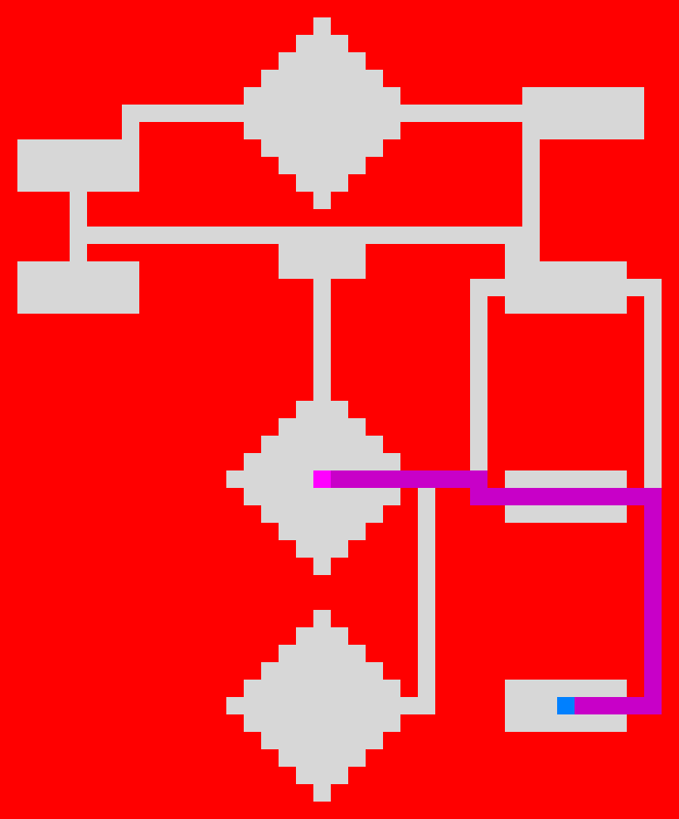

- Task2:
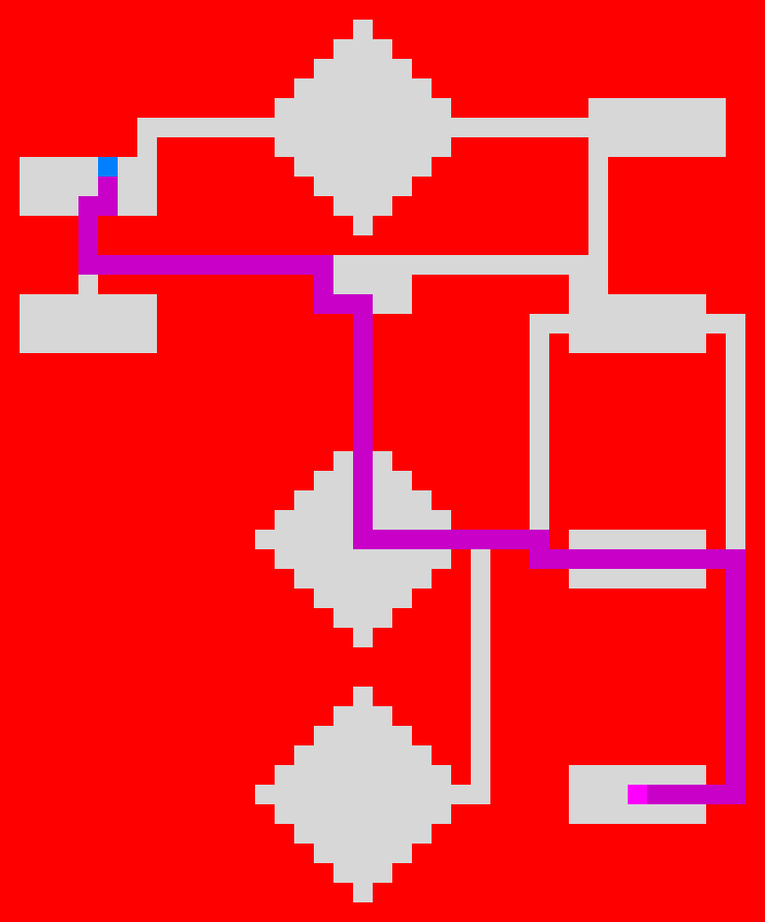

Part 2:

Source Code found in AStar.py

- Task 3:
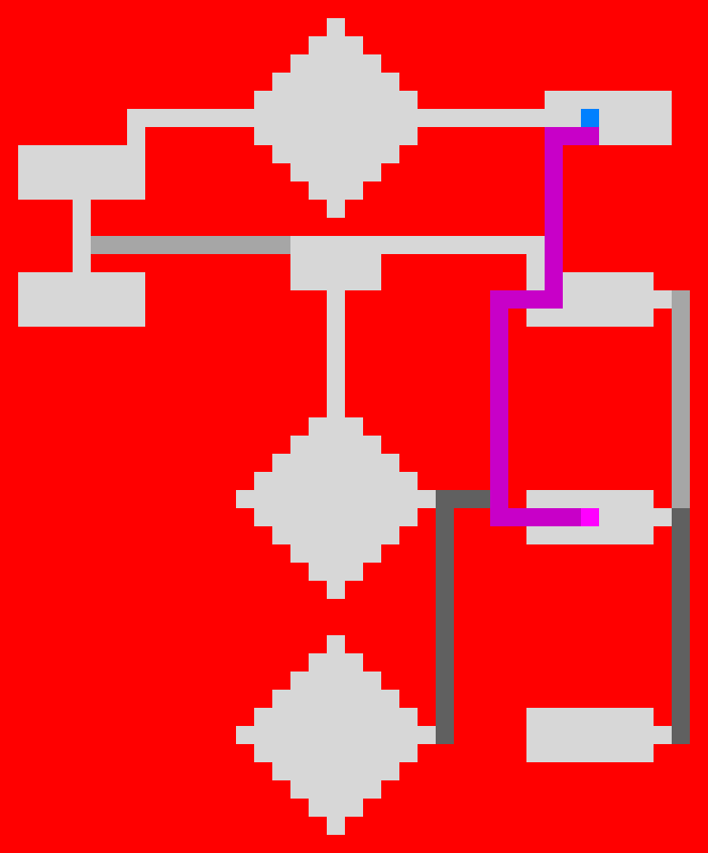

- Task 4:

